ESTIMATING
Pearson Edexcel - Tuesday 19 May 2020 - Paper 1 (Non-Calculator) Higher Tier
1.
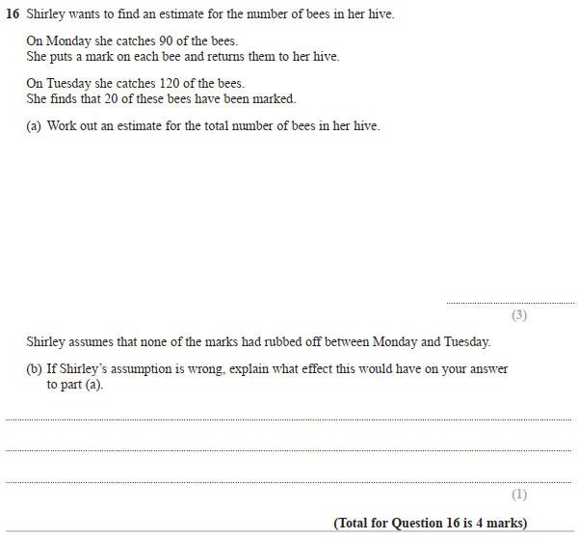

Pearson Edexcel – Monday 8 June 2020 - Paper 3 (Calculator) Higher Tier
2.
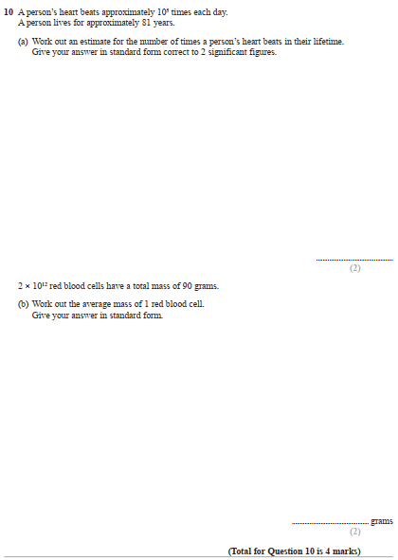

Pearson Edexcel – Monday 8 June 2020 - Paper 3 (Calculator) Higher Tier
3.
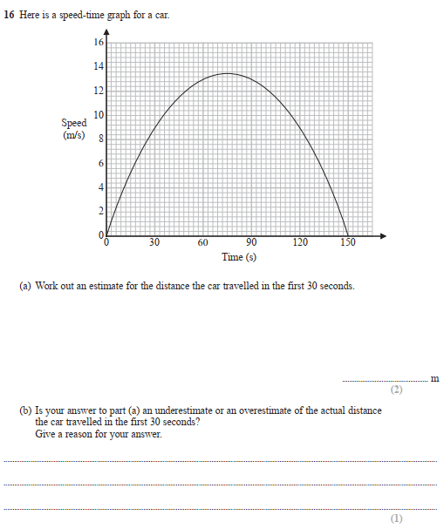
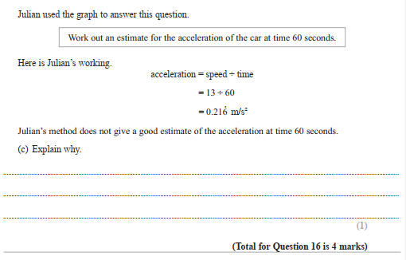

Pearson Edexcel – Monday 8 June 2020 - Paper 3 (Calculator) Higher Tier
4.
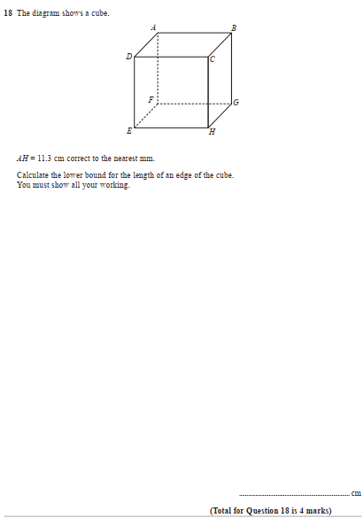

Pearson Edexcel - Tuesday 21 May 2019 - Paper 1 (Non-Calculator) Higher Tier
5.
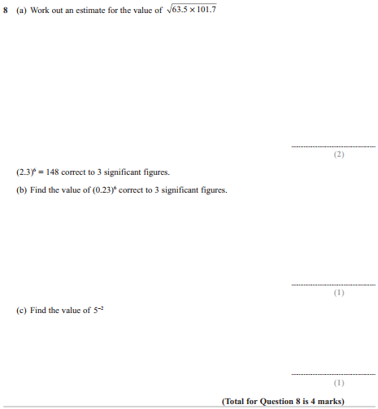

Pearson Edexcel - Thursday 6 June 2019 - Paper 2 (Calculator) Higher Tier
6.
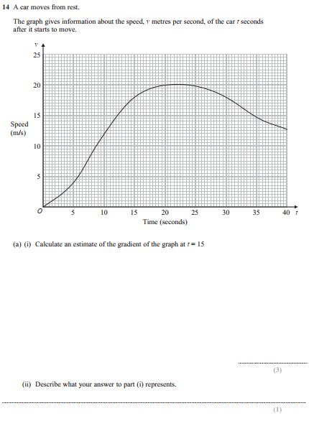
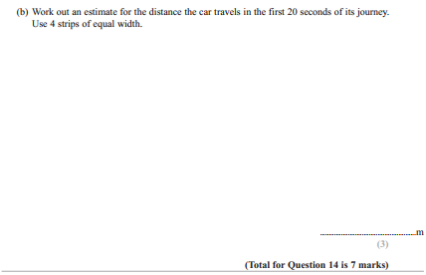
Pearson Edexcel - Tuesday 6 November 2018 - Paper 1 (Non-Calculator) Higher Tier
7.
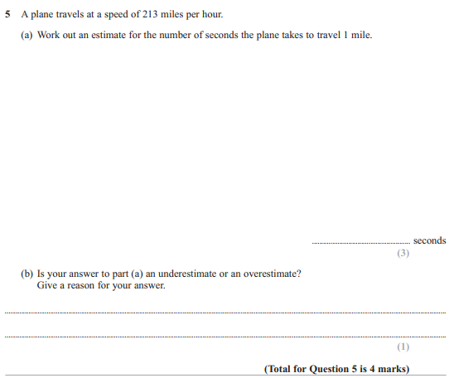

Pearson Edexcel - Thursday 24 May 2018 - Paper 1 (Non-Calculator) Higher Tier
8.
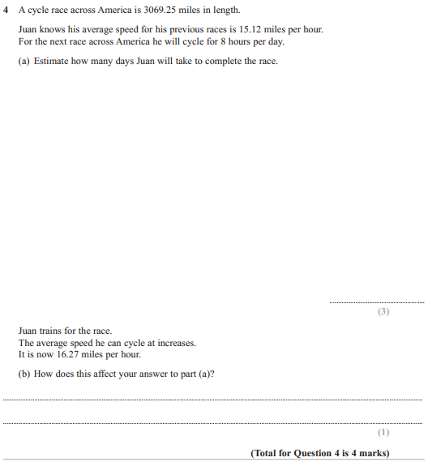

Pearson Edexcel - Tuesday 12 June 2018 - Paper 3 (Calculator) Higher Tier
9.
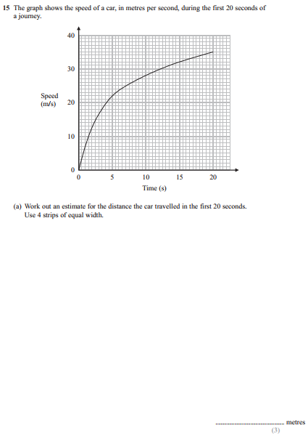
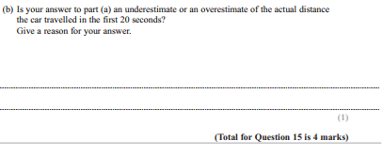
Pearson Edexcel - Tuesday 12 June 2018 - Paper 3 (Calculator) Higher Tier
10.
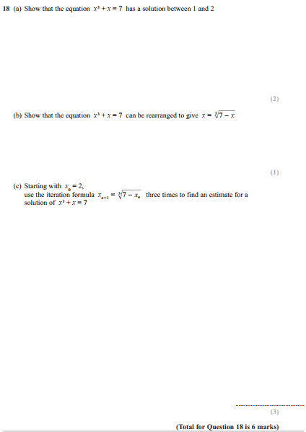

Pearson Edexcel - Thursday 2 November 2017 - Paper 1 (Non-Calculator) Higher Tier
11.
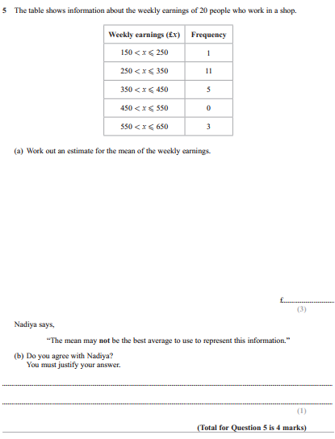

Pearson Edexcel - Wednesday 8 November 2017 - Paper 3 (Calculator) Higher Tier
12.
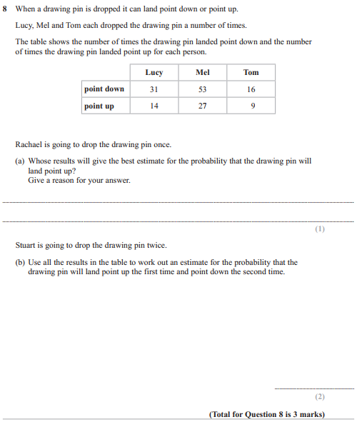

Pearson Edexcel - Wednesday 8 November 2017 - Paper 3 (Calculator) Higher Tier
13.
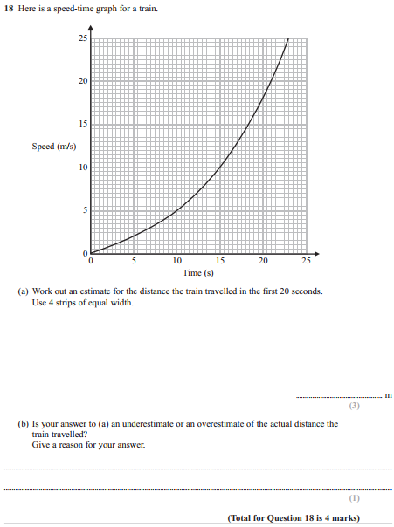

Pearson Edexcel - Thursday 25 May 2017 - Paper 1 (Non-Calculator) Higher Tier
14.
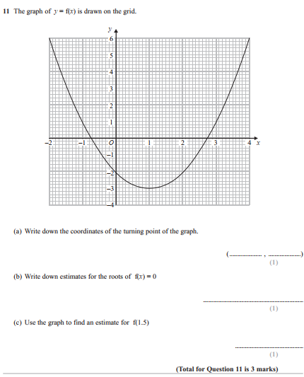

Pearson Edexcel - Thursday 8 June 2017 - Paper 2 (Calculator) Higher Tier
15.
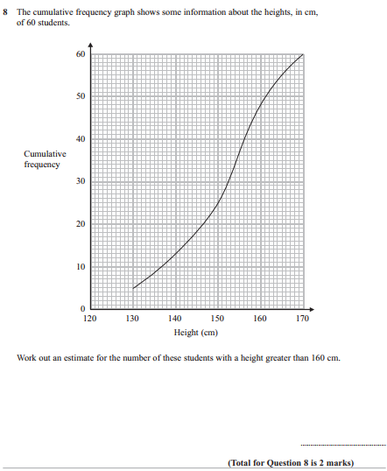

Pearson Edexcel - Thursday 8 June 2017 - Paper 2 (Calculator) Higher Tier
16.
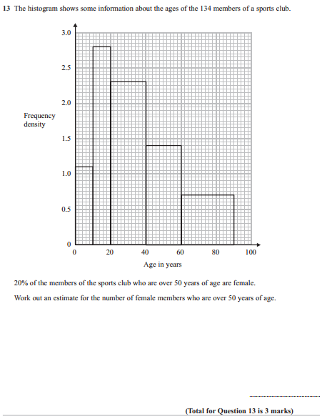

Pearson Edexcel - Thursday 8 June 2017 - Paper 2 (Calculator) Higher Tier
17.
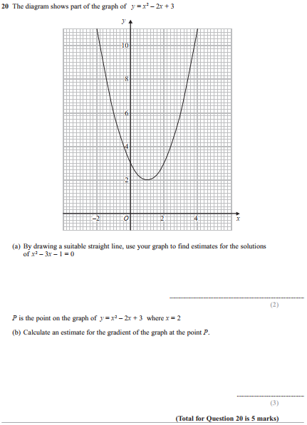

Pearson Edexcel - Specimen Papers Set 2 - Paper 1 (Non-Calculator) Higher Tier
18.
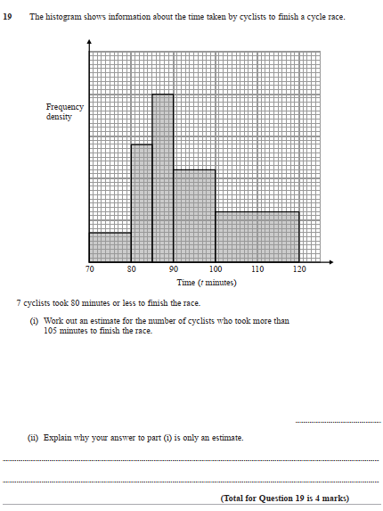

Pearson Edexcel - Specimen Papers Set 2 - Paper 2 (Calculator) Higher Tier
19.
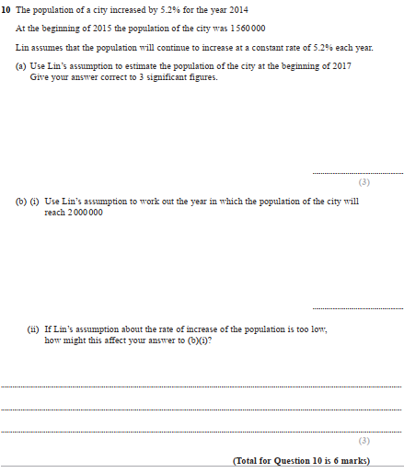

Pearson Edexcel - Specimen Papers Set 2 - Paper 2 (Calculator) Higher Tier
20.
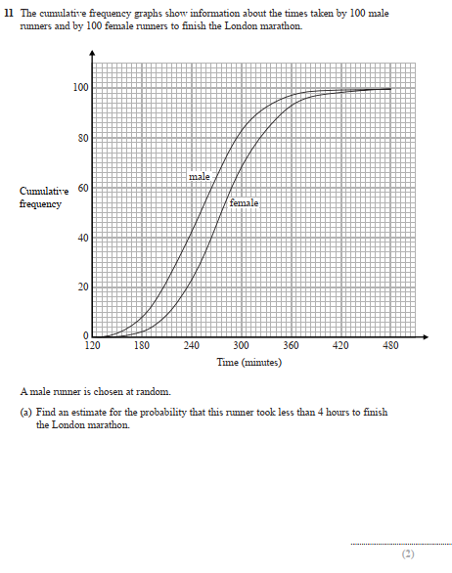
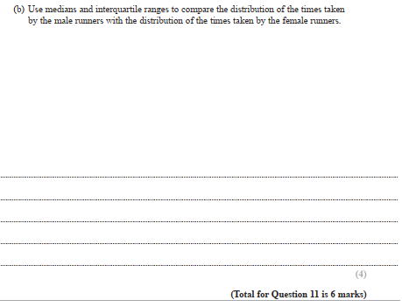

Pearson Edexcel - Specimen Papers Set 2 - Paper 2 (Calculator) Higher Tier
21.
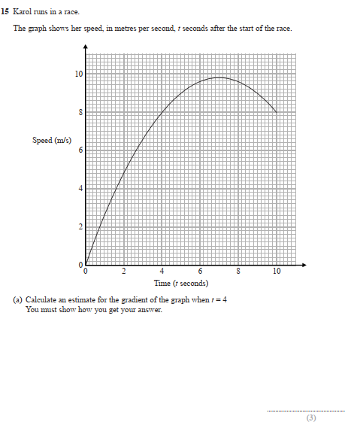
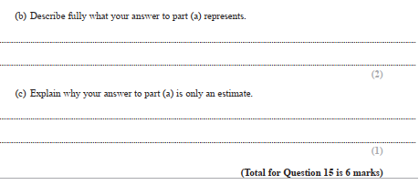
Pearson Edexcel - Specimen Papers Set 2 - Paper 3 (Calculator) Higher Tier
22.
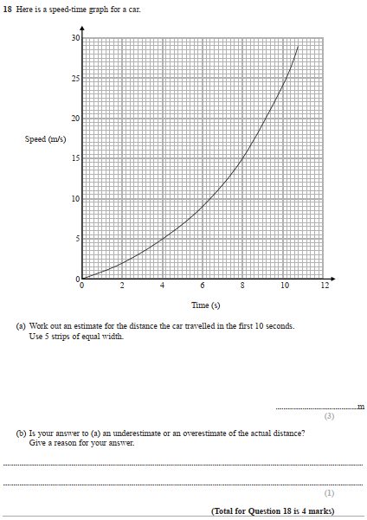

Pearson Edexcel - Specimen Papers Set 1 - Paper 1 (Non-Calculator) Higher Tier
23.
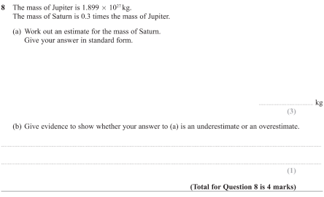

Pearson Edexcel - Specimen Papers Set 1 - Paper 2 (Calculator) Higher Tier
24.
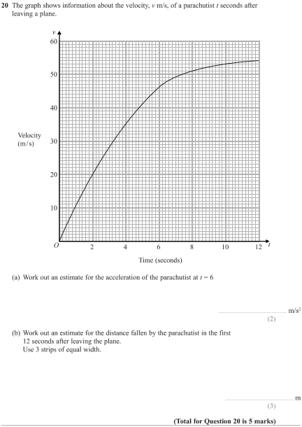

Pearson Edexcel - Specimen Papers Set 1 - Paper 3 (Calculator) Higher Tier
25.
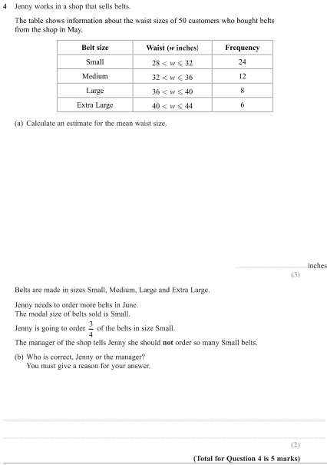

Pearson Edexcel - Specimen Papers Set 1 - Paper 3 (Calculator) Higher Tier
26.
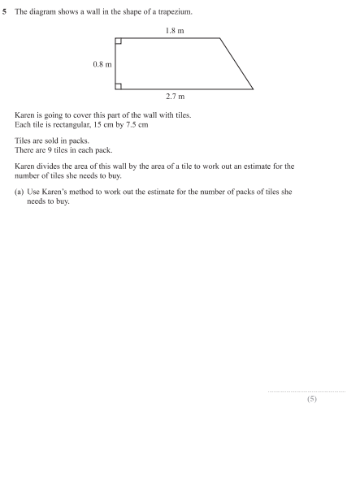
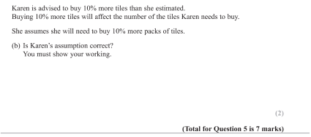
Pearson Edexcel - Specimen Papers Set 1 - Paper 3 (Calculator) Higher Tier
27.
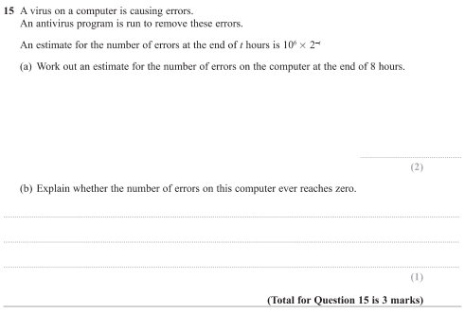
Pearson Edexcel - Sample Paper 1 - (Non-Calculator) Higher Tier
28.
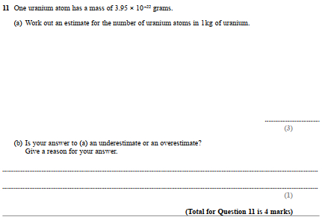
Pearson Edexcel - Sample Paper 2 - (Calculator) Higher Tier
29.
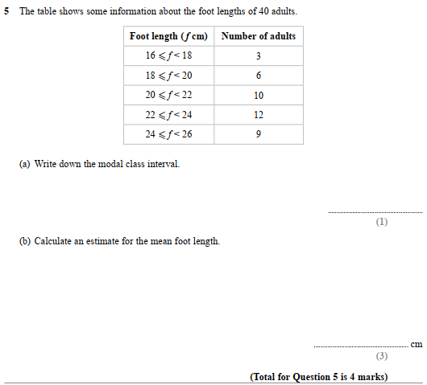

Pearson Edexcel - Thursday 26 May 2016 - Paper 1 (Non-Calculator) Higher Tier
30.
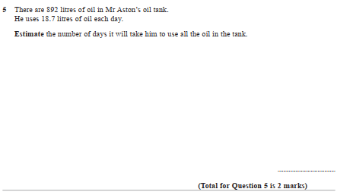
Pearson Edexcel - Thursday 26 May 2016 - Paper 1 (Non-Calculator) Higher Tier
31.
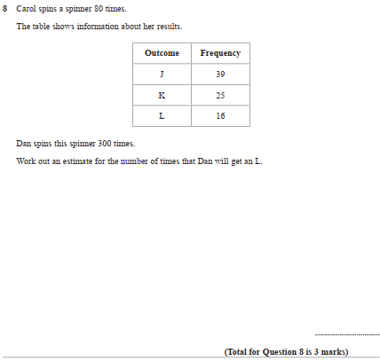
Pearson Edexcel - Thursday 9 June 2016 - Paper 2 (Calculator) Higher Tier
32.
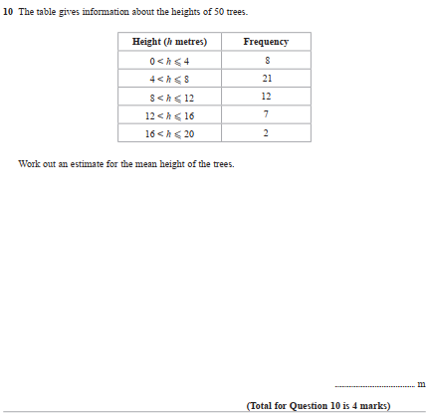

Pearson Edexcel - Thursday 9 June 2016 - Paper 2 (Calculator) Higher Tier
33.
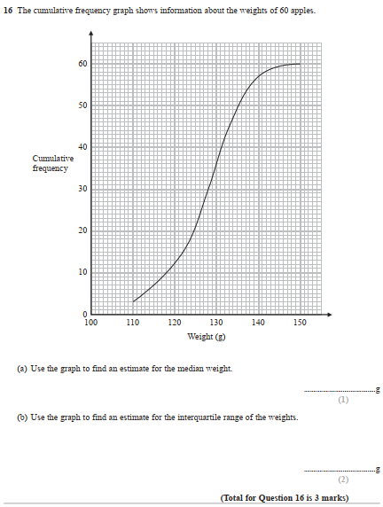

Pearson Edexcel - Thursday 4 June 2015 - Paper 1 (Non-Calculator) Higher Tier
34.
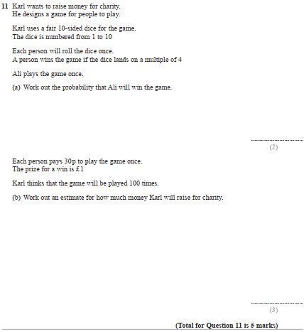

Pearson Edexcel - Monday 8 June 2015 - Paper 2 (Calculator) Higher Tier
35.
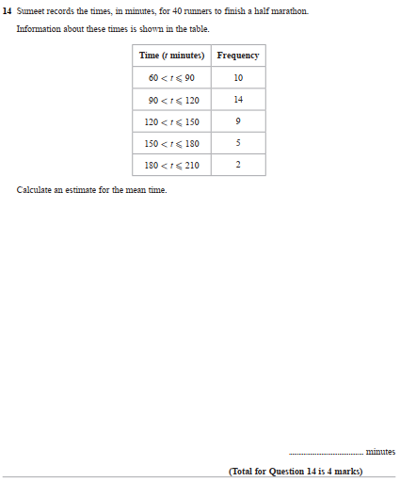

Pearson Edexcel - Monday 9 June 2014 - Paper 1 (Non-Calculator) Higher Tier
36.
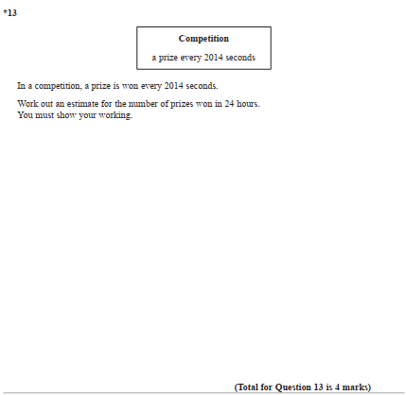
Pearson Edexcel - Tuesday 11 June 2013 - Paper 1 (Non-Calculator) Higher Tier
37.
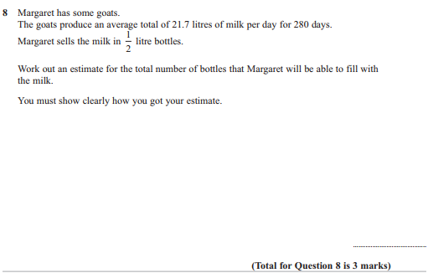
Pearson Edexcel - Tuesday 6 November 2012 - Paper 1 (Non-Calculator) Higher Tier
38.
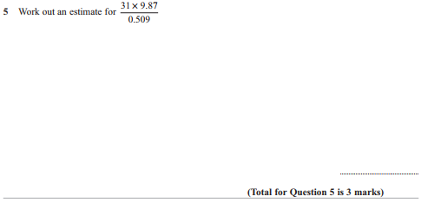

Pearson Edexcel - Monday 5 March 2012 - Paper 4 (Calculator) Higher Tier
39.
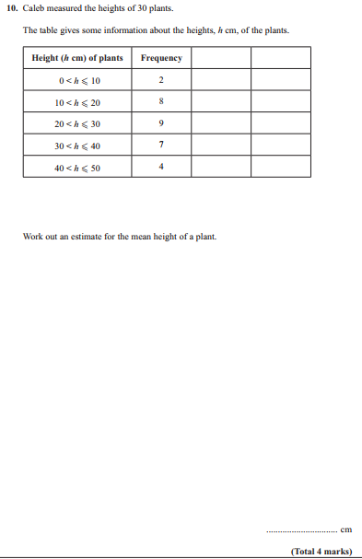
Pearson Edexcel - Wednesday 9 November 2011 - Paper 3 (Non-Calculator) Higher Tier
40.
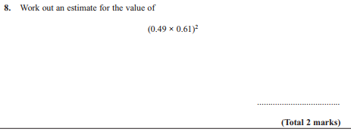
Pearson Edexcel - Wednesday 9 November 2011 - Paper 3 (Non-Calculator) Higher Tier
41.
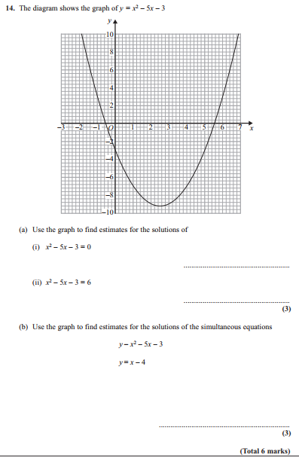

Pearson Edexcel - Monday 14 November 2011 - Paper 4 (Calculator) Higher Tier
42.
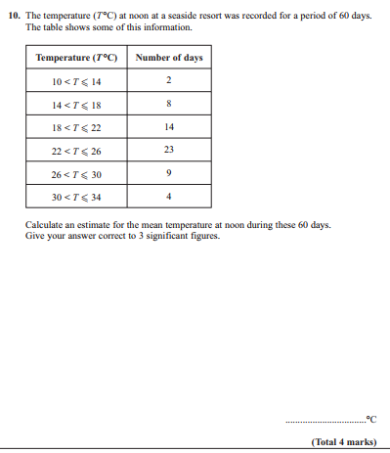

Pearson Edexcel - Monday 6 June 2011 - Paper 3 (Non-Calculator) Higher Tier
43.
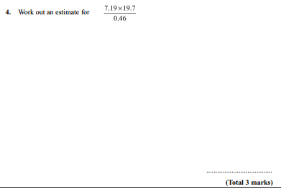

Pearson Edexcel - Tuesday 9 November 2010 - Paper 3 (Non-Calculator) Higher Tier
44.
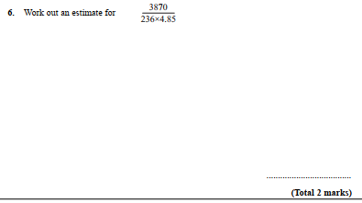

Pearson Edexcel - Friday 11 June 2010 - Paper 4 (Calculator) Higher Tier
45.
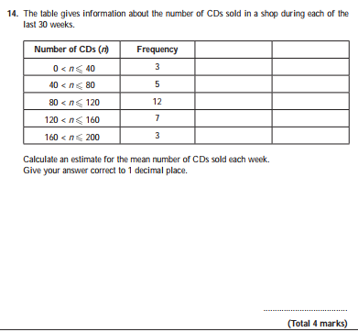

Pearson Edexcel - Thursday 5 November 2009 - Paper 3 (Non-Calculator) Higher Tier
46.
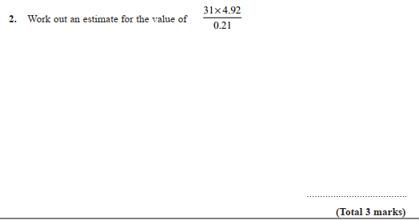

OCR GSCE – Thursday 7 November 2019 – Paper 5 (Non-Calculator) Higher Tier
47.
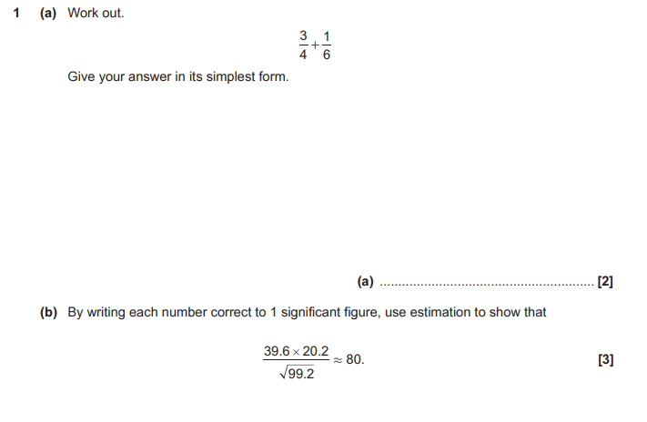

OCR GSCE – Thursday 7 June 2018 – Paper 5 (Non - Calculator) Higher Tier
48.
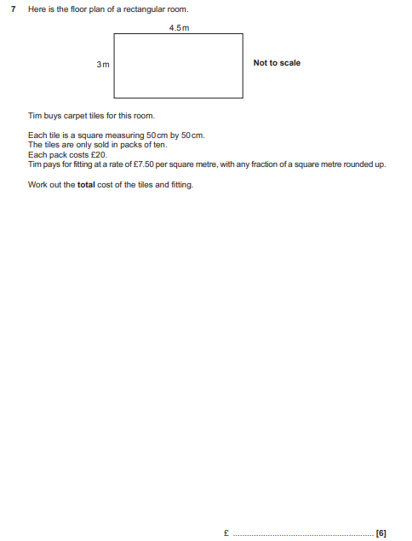

OCR GSCE – Sample Papers – Paper 4 (Calculator) Higher Tier
49.
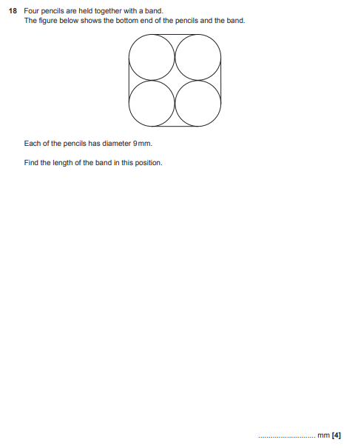

OCR GSCE – Sample Papers – Paper 6 (Calculator) Higher Tier
50.
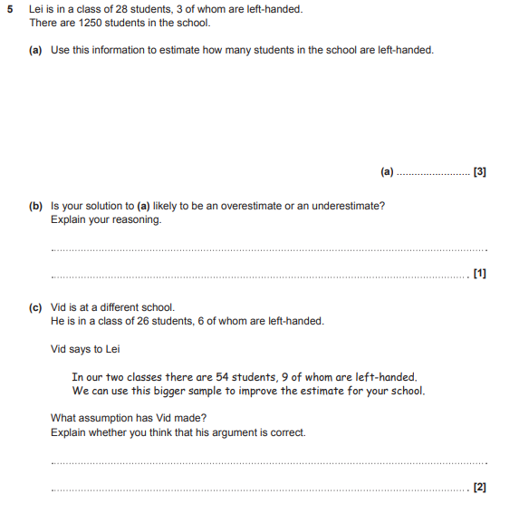

AQA GSCE – Thursday 8 June 2020 – Paper 3 (Calculator) Higher Tier
51.
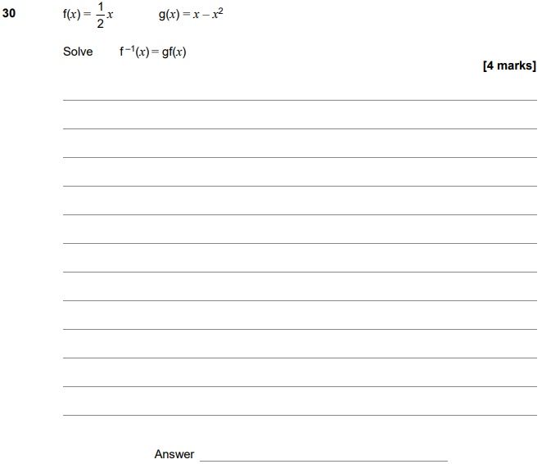

AQA GSCE – Thursday 6 June 2019 – Paper 2 (Calculator) Higher Tier
52.
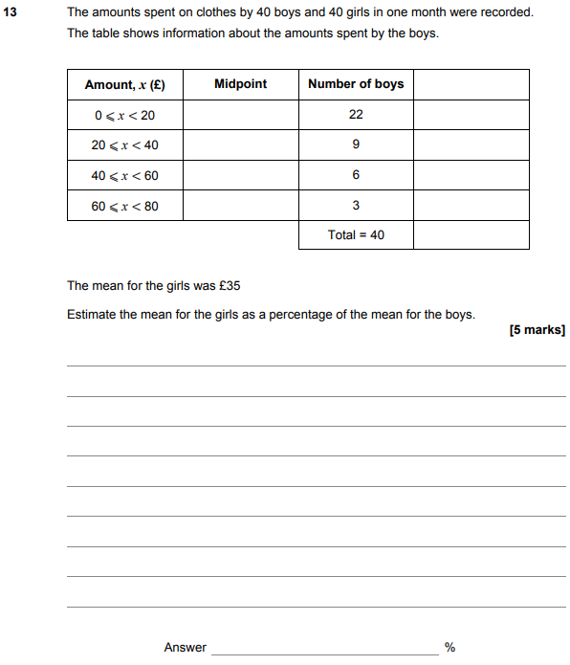

AQA GSCE – Tuesday 11 June 2019 – Paper 3 (Calculator) Higher Tier
53.
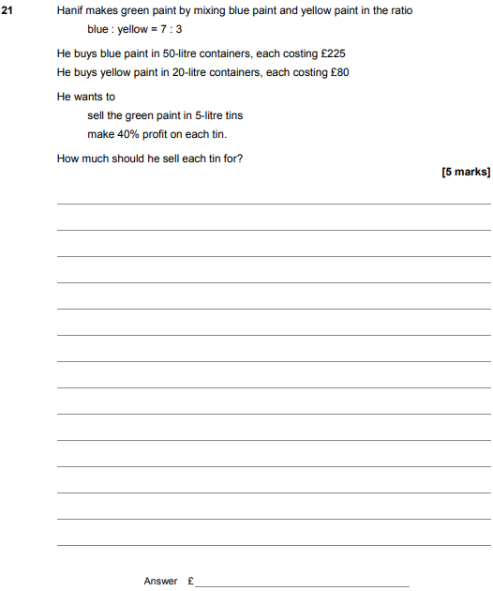

AQA GSCE – Thursday 8 November 2018 – Paper 2 (Calculator) Higher Tier
54.
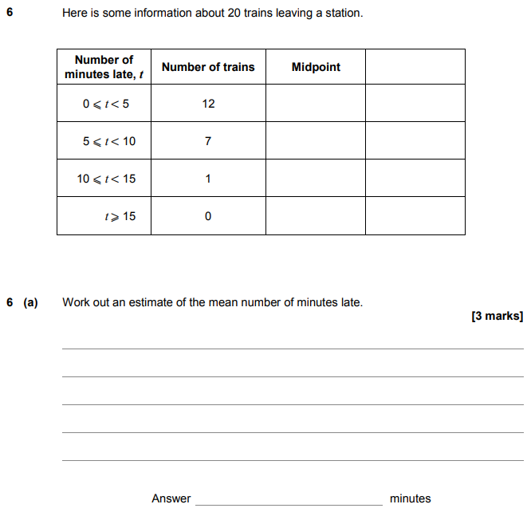
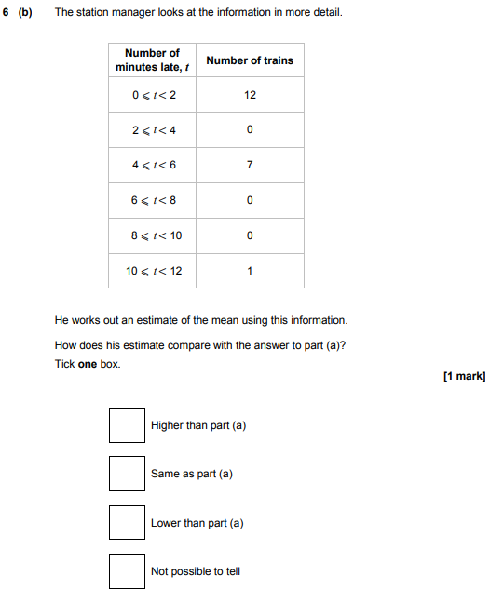

AQA GSCE – Thursday 8 November 2018 – Paper 2 (Calculator) Higher Tier
55.
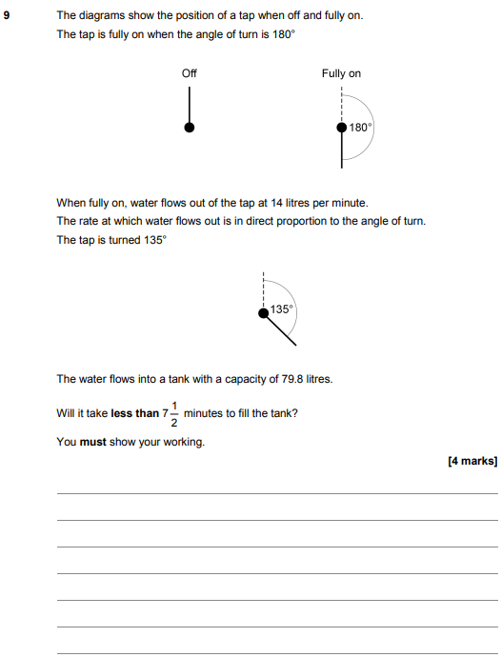

AQA GSCE – Monday 12 November 2018 – Paper 3 (Calculator) Higher Tier
56.
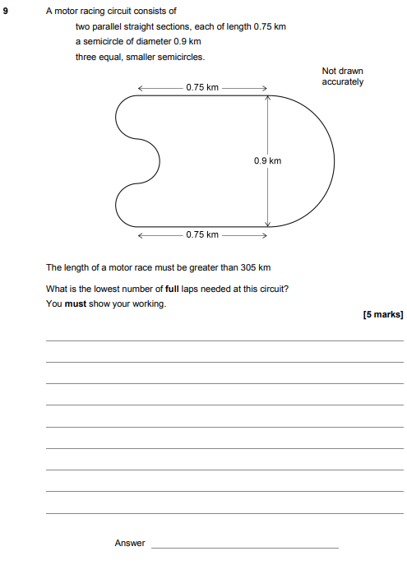

AQA GSCE – Thursday 2 November 2017 – Paper 1 (Non - Calculator) Higher Tier
57.
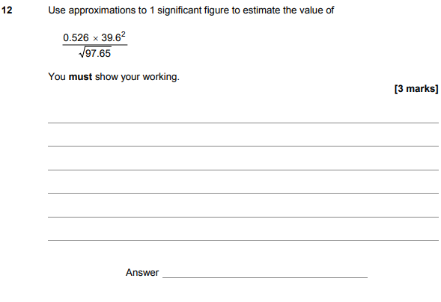
AQA GSCE – Sample Paper 3 (Calculator) Higher Tier
58.

